

predoct!

**A disease diagnostic error reduction and data transformation machine**



**Department ofElectronic Engineering**

**NED University of Engineering & Technology**

**University Road – 75300**

**Karachi**

**Project Advisor**

Mr. Shehzad Siddiqi

Assistant Professor

**Group Members:**

Hafiz Abdullah (El-112)

Mustafa Arif (El-127)

Mufaddal Idrees Dawson (El-129)

Muhammad Umair (El-130)

**Table of Contents**

1. Introduction
   1. Scope of the Project
   2. Motivation and Need
   3. Objectives
2. Related Work
3. Data Collection
   1. Lung Anatomy
   2. Data Segmentation
   3. Data Annotation
   4. Data Normalizing
   5. Grayscale Thresholding
      1. Gray-level thresholding
      2. Otsu’s thresholding
4. Expected Results
5. Future tasks
6. Conclusion
7. References
8. **Introduction**

Cancer is a leading cause of death in world. According to a report from International Agency for Research on Cancer (IARC)in 2018, lung cancer is the most common cancer around the world recorded 2.09 million cases [1], and 3rd most common cancer in Pakistanrecorded 9,771 cases [2]. Around 1.76 million deaths were recorded due to lung cancer around the world in 2018. One of the reasons behind these deaths is lack of early detection of nodules (cancer cells). To assist this issue, we came up with a solution which can help to detect the nodule at an early stage.

Computed tomography (CT) scan is one of the initial tests which can help in recognizing the cancer, followed by other scans i.e. MRI, Biopsy etc. (if required). CT produce a 3-dimensional image of chest, resulting in greater resolution of nodules and tumor pathology [3].

According to the radiologists, detection and classification of lung nodule is a difficult task and sometimes it causes in negative-report. Computer Aided Diagnosis (CAD) systems are designed to support the clinical experts/radiologist decision. These CAD systems can differentiate between benign and malignant lung nodules using deep learning techniques.

Deep learning is a growing field in designing computer aided/automated systems. Today, several computer-based systems are performing well then human being i.e. identifying the tumor in the CT scan images. It is possible due to the advancement of neural network that provides higher level of abstraction and improved image analysis.[4]

**1.1 Scope of the Project**

"Providing an accurate medical diagnosis is complex and involves uncertainty, but it's obviously essential to effective and timely treatment," Paul Epner-chief executive officer and co-founder of SIDM, (Society to Improve Diagnosis in Medicine)

This project is intended to assist doctors in a way that it would save their time and enhance their decision making, by using state of the art technologies like AI, machine learning, and computer vision.

Artificial intelligence (AI) in medicine is a fast-growing field, generating hopes and raising perplexing issues. AI can be defined as the ability for a computer to mimic the cognitive abilities of a human being. AI corresponds to a large array of techniques. Among them, machine learning is one of the most relevant approaches in the medical field.

**1.2 Motivation and Need**

We believe that human physicians/radiologist will not be replaced by machines in the foreseeable future, but AI can definitely assist them to make better clinical decisions or even replace human judgment in certain functional areas of healthcare.

Diagnosing patients according by examining medical images is a prime candidate for the application of AI systems to improve both the speed and accuracy of performing these tasks.

In particular, medical imaging is ideal for AI because we already possess a wealth of medical scans, collected, categorized and stored at medical institutions across the world, many of which are digital, or undergoing the digitization process.  These massive collections of image data can be used to train AI systems not only to perform the collection and categorization of scans, but to analyze these medical images to identify a myriad of health conditions

Even the most skilled doctor or radiologist is capable of a misdiagnosis due to how difficult it can be to distinguish specific diseases based on CT scans. An AI system can help to reduce diagnostic and therapeutic errors that are inevitable in the human clinical practice. Moreover, an AI system extracts useful information from a large patient population to assist making real-time inferences for health risk alert and health outcome prediction

The motivation behind this work is to have a deep learning model to aid in the interpretation task that could overcome the intrinsic limitations of human perception and bias, and reduce errors, more broadly, we believe that a deep learning model for this purpose could improve health care delivery across a wide range of settings.

**1.3 Objectives**

* Collect labeled data for the training and testing of the neural network.
* Train a neural network model with highest possible efficiency.
* Create a handy user interface for the collection of patient’s medical record.
* Understand cancer disease: symptoms, causes, stages and treatments.
* Create a setup for the manipulation of data of patients collected on daily basis.
* Design a method for the data transfer to the doctor.

1. **Related Work**

Chen et al. [5] proposed a method that uses a neural network ensemble (NNE) scheme to distinguish probably benign and uncertain and probably malignant lung nodules. Experimental results illustrated that the scheme had classification accuracy (78.7%) which is better than that of the individual classifier (LVQNN: 68.1%).

Kuruvilla and Gunavathi [6] proposed a methodology based on texture features using the artificial neural network (ANN), with an accuracy rate of 93.30%.

Kumar et al. [7] presented a methodology using the stacked autoencoder (SAE), a deep learning technique, with an accuracy rate of 75.01%.

In 2014, Kulkarni and Panditrao [8] proposed an automatic tumor staging system from chest CT scans using marker-controlled watershed and Support Vector Machine (SVM).

Similarly, Ignatious et al. (2015) [9] applied marker-controlled watershed for lung tumor detection and staging.

A multi-stage cancer detection method using watershed and multi-class SVM classifier was also proposed by Alam et al. (2018) [10]

Recently, deep learning models have made great breakthroughs for machine learning [11]. Convolutional Neural Networks (CNNs) are the most frequently used deep learning model for the automated detection of lung tumors. However, for staging, CNN has been applied in very few studies. Kirienko et al. (2018) [12] developed a CNN for T1–T2 or T3–T4 staging of lung tumors.

1. **Data Collection**

The data is collected from multiple sources including Lung Image Database Consortium and Image Database Resource Initiative (LIDC/IDRI), Cancer Imaging Archive,Kaggle and Lung Nodule Analysis 2016(LUNA 16). The dataset consists of labeled and unlabeled CT scan images. The labeled CT scan images are categorized in benign and malignant scans. The challenge to handle this data is to analyze the nodule position and size, these images need to be divided into slices and the affected area is to be analyzed. For this reason, assistance from a senior radiologist from National Institute of Child Health(N.I.C.H) is been taken.

**3.1 Lung Anatomy**

As shown in figure a, there are two significant organs: the left and the right lung. Each is limited by a pleural sac with two membranes called visceral pleura (inward layer featured by the dark edge) and parietal pleura (external film featured by the blue edge). These layers ensure and join the lungs to the thoracic cavity. A twofold crease of visceral pleura called the lung fissure divides the lungs into separate lobes.The left lung is around 10% smaller than the privilege because of heart space in the thorax [13]. Along these lines, the left lung has just two lobes (upper and lower) which are isolated by an oblique fissure, while the right lung has three lobes (upper, center and lower) which are isolated by oblique and horizontal fissure. As the essential capacity of the lungs is to do gas trade, 80–90% of their region is loaded up with low thickness air having −1000 Hounsfield Unit (HU) [14]. The windpipe, otherwise called the trachea (meant by green shading), conveys the air from the throat to the lungs and enters every lung by stretching into two primary bronchi (left demonstrated in darker and right showed in dim blue) at the anatomical point called the carina. The correct principle bronchus further parts into three lobar bronchi which enter lobes of the right lung. In like manner, the left bronchus parts into two lobar bronchi for each left lung lobe. These bronchi experience various divisions, framing the bronchial air route tree. Like the bronchial air route framework, pulmonary vessels additionally branch all through the lungs in a tree structure. The pulmonary vascular tree completes the transportation of deoxygenated blood from the heart to the lungs to perform oxygenation, while the bronchial air route tree bolsters the progression of oxygen to the lung structures, including the pulmonary vessels [15]. Both of these trees enter and leave the lungs through a spot called the hilum (indicated by the green specked oval).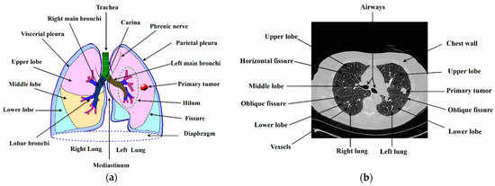

Figure b shows the lung formation on the CT screen. As we can see on the screen, there are two different elements: the air (black regions) and the human body (gray regions) [14]. These two components have different radiography in which the air (−1000 HU) has a much lower mass than the human body (−400 HU to 1000 HU). The human body contains elements such as parenchyma or regions of the lungs, fluid, fat, soft tissues, bones and vessels. The radiation intensity of these components is different from each other indicating different gray levels in the CT scan.

**3.2 Data segmentation**

For data segmentation, it is important to have background pulmonary anatomy knowledge. We briefly study the lungs anatomy and its appearance on CT scan. The knowledge is applied to separate all the irrelevant images and keep all the relevant images for further processing.

The collected CT scan results were in the form of Digital Imaging & Communications (dicom) video format. For further processing, the data is divided into frames to produce useful images. In addition to this, these images were divided in different frames to discard the CT scans having inconsistent or missing slices.

**3.3 Data annotation**

After the data is classified, zero ‘0’ label was assigned to the irrelevant images and the relevant images were assigned with the initial result provided in the dataset.

**3.4 Data normalizing**

Originally, the resolutions of 3-channel images were between 0-255 pixels, after applying normalization techniques, the resolution was adjusted between 0 to 1 pixel.

**3.5Grayscale thresholding**

After lowering the pixels of the images, a threshold of 0.5 was set. Images having pixels between 0-0.5 were scaled to zero’0’ and the images having pixel greater than 0.5 were scaled to 1.

**3.5.1 Gray-levelthresholding**

Many experts have proposed different methodologies for segmentation of lung anatomical structures. We applied gray level thresholding on account of its quick and direct procedure. To segment the region of interest (ROI), thresholding replaces an image pixel with a dim one in case it has a gray level below the specified threshold value.

If $g\left(P_{\left(x,y\right)}\right)<T$, then $P_{\left(x,y\right)}$ =0, else $P_{\left(x,y\right)}$ =1

Where,

$g\left(P_{\left(x,y\right)}\right)$ is gray value of the image pixel $P_{\left(x,y\right)}$

T is threshold gray value.

As we talked about, the lung anatomical structures are apportioned in a specific gray level range on a CT scan. They show up in a range among highly contrasting; for instance, the air seems dark, the liquid seems gray, delicate tissues seem different shades of gray, bones seem thick white, and vessels seem white. Be that as it may, each pixel of every particular region speaks to an individual gray value that is identified with the mean radiographic density of the lung anatomical structures [16].

After observing the effect of gray level thresholding, we arrived at a conclusion that this technique creates noise signal, which makes the detection of nodule further troublesome. So, we dispose of this approach and move to another technique called Otsu’s thresholding.

**3.5.2 Otsu’s thresholding**

Otsu’s method is based on threshold selection by statistical criteria. Otsu's algorithm is more sophisticated way of image thresholding as compared to traditional mean-based split of gray-level image into binary image. This sophistication comes from minimizing the weighted **within-class** variance and maximizing between-class variance.

Otsu’s algorithm attempts to find a threshold value (t) which minimizes the weighted within-class variance given by the relation:

$$σ_{ω}^{2}\left(t\right)=q_{1}\left(t\right)σ_{1}^{2}\left(t\right)+q_{2}\left(t\right)σ_{2}^{2}\left(t\right)$$

Where,

$$q_{1}\left(t\right)=\sum_{i=1}^{t}{P(i)}$$

$$q_{2}\left(t\right)=\sum_{i=t+1}^{I}{P(i)}$$

$$μ_{1}\left(t\right)=\sum_{i=1}^{t}{\frac{iP(i)}{q_{1}(t)}}$$

$$μ_{2}\left(t\right)=\sum_{i=t+1}^{I}{\frac{iP(i)}{q_{2}(t)}}$$

$$σ_{1}^{2}\left(t\right)=\sum_{i=1}^{t}{{[i-μ_{1}\left(t\right)]}^{2}\frac{P(i)}{q_{1}(t)}}$$

$$σ_{2}^{2}\left(t\right)=\sum_{i=t+1}^{I}{{[i-μ_{2}\left(t\right)]}^{2}\frac{P(i)}{q_{2}(t)}}$$

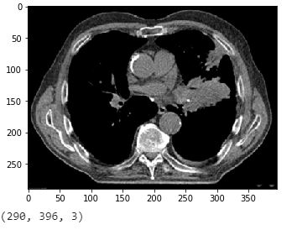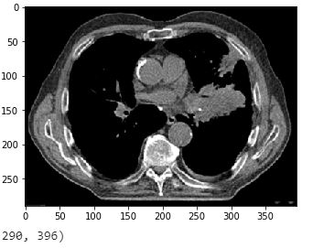

(a)Raw Image (b)Gray scaled

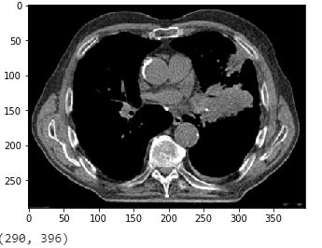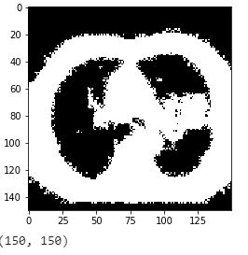

(c) Normalized (d)Gray-level thresholding

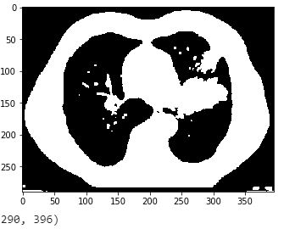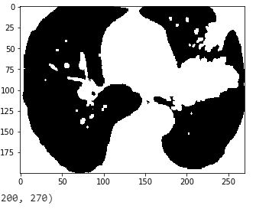

(e)Otsu’s thresholding (f) Region of Interest(ROI)

1. **Expected Results**

The model built using above preprocessed dataset will give more optimized and accurate results.

It will predict weather the provided CT scan contains a lung cancer or not, if yes then a classification will be predicted that which type of nodule is detected and the disease is in which stage.

1. **Future tasks**

After the data is being preprocessed, the next step is the designing and the implementation of neural network to which these images will be fed to predict the results. A doctor patient interface would be design to keep a track of each and every patient for future references.

1. **Conclusion**

In order to get more accurate results, the convent neural network should be fed with a data which is completely and properly preprocessed and all the irrelevant data should be discarded, only the most relevant and cleaned data should be selected for further processing. By adopting these techniques, the convent neural network would predict a result with greater accuracy.

1. **References**

[1] International Agency for Research on Cancer(IARC),2018 <https://www.who.int/news-room/fact-sheets/detail/cancer>

[2]International Agency for Research on Cancer(IARC),2018<https://gco.iarc.fr/today/data/factsheets/populations/586-pakistan-fact-sheets.pdf>

[3] QingZeng Song, Lei Zhao, XingKe Luo, and XueChen Dou, “Using Deep Learning for Classification of Lung Nodules on Computed Tomography Images”, Published 9 August 2017.

[4] Muhammad Imran Razzak, Saeeda Naz and Ahmad Zaib, “Deep Learning for Medical Image Processing: Overview, Challenges and Future”.

[5] H. Chen and W. WuH. Xia, J. Du, M. Yang, and B. Ma, “Classification of pulmonary nodules using neural network ensemble,” in Advances in Neural Networks, pp. 460–466, Springer, Guilin, China, 2011.

[6] J. Kuruvilla and K. Gunavathi, “Lung cancer classification using neural networks for CT images,” Computer Methods and Programs in Biomedicine, vol. 113, no. 1, pp. 202–209, 2014

[7] D. Kumar, A. Wong, and D. A. Clausi, “Lung nodule classification using deep features in CT images,” in 12th Conference on Computer and Robot Vision (CRV), pp. 133–138, IEEE, 2015.

[8] Kulkarni, A.; Panditrao, A. Classification of lung cancer stages on CT scan images using image processing. In Proceedings of the 2014 IEEE International Conference on Advanced Communications, Control and Computing Technologies, Ramanathapuram, India, 8–10 May 2014; IEEE: Ramanathapuram, India, 2014; pp. 1384–1388.

[9] Ignatious, S.; Joseph, R.; John, J.; Prahladan, A. Computer Aided Lung Cancer Detection and Tumor Staging in CT image using Image Processing. *Int. J. Comput. Appl.* **2015**, *128*, 29–33.

[10] Alam, J.; Alam, S.; Hossan, A. Multi-Stage Lung Cancer Detection and Prediction Using Multi-class SVM Classifie. In Proceedings of the 2018 International Conference on Computer, Communication, Chemical, Material and Electronic Engineering (IC4ME2), Rajshahi, Bangladesh, 8–9 February 2018; IEEE: Rajshahi, Bangladesh, 2018; pp. 1–4.

[11] Jiao, Z.; Gao, X.; Wang, Y.; Li, J.; Xu, H. Deep Convolutional Neural Networks for mental load classification based on EEG data. *Pattern Recognit.* **2018**, *76*, 582–595.

[12] Kirienko, M.; Sollini, M.; Silvestri, G.; Mognetti, S.; Voulaz, E.; Antunovic, L.; Rossi, A.; Antiga, L.; Chiti, A. Convolutional Neural Networks Promising in Lung Cancer T-Parameter Assessment on Baseline FDG-PET/CT. *Contrast Media Mol. Imaging* **2018**, *2018*, 1382309.

[13]Sylvan, E. CT-Based Measurement of Lung Volume and Attenuation of Deceased. Master’s Thesis, Linköpings Universisty, Linköping, Sweden, 23 September 2005.

[14] Zhou, X.; Hayashi, T.; Hara, T.; Fujita, H.; Yokoyama, R.; Kiryu, T.; Hoshi, H. Automatic segmentation and recognition of anatomical lung structures from high-resolution chest CT images. *Comput. Med. Imaging Graph.* **2006**, *30*, 299–313.

[15]Walker, C.M.; Rosado-de-Christenson, M.L.; Martínez-Jiménez, S.; Kunin, J.R.; Wible, B.C. Bronchial Arteries: Anatomy, Function, Hypertrophy, and Anomalies. *RadioGraphics* **2015**, *35*, 32–49.

[16] Drummond, G.B. Computed tomography and pulmonary measurements. *Br. J. Anaesth.* **1998**, *80*, 665–671. [[**Google Scholar**](https://scholar.google.com/scholar_lookup?title=Computed+tomography+and+pulmonary+measurements&author=Drummond,+G.B.&publication_year=1998&journal=Br.+J.+Anaesth.&volume=80&pages=665%E2%80%93671&doi=10.1093/bja/80.5.665&pmid=9691874)] [[**CrossRef**](https://dx.doi.org/10.1093/bja/80.5.665)] [[**PubMed**](https://www.ncbi.nlm.nih.gov/pubmed/9691874)]